Coursework Report - Dynamic Control Experiments and Analysis

Student name : Laura Romero Carrillo

Student number: 1610246

Date: 14/12/2017

Course code: 5CCS2ITR

Introduction

Methodology

Experimental Results

- report the mininmum sample interval your code could achieve

The sample interval that our code works at is 10ms per cycle. It mostly stable though we made sure it would accept something greater than that to accommodate for problems with the system.

The P Controler

By tuning the value 4.5 for Kp for the step response, we achieved a steady state error of 0.01 radians. This is an appropriate value given that it prevents overshoot whilst still allowing for the arm to reach a approximate goal position. The rise time for this was 522 ms, which was within the limits set our for this expeiment. Similarly, the value of 12.5 for the harmonic response gave us a more varying steady state error due to the nature due the sine wave which changes from negative to positive, which we managed to limit to a range of -0.13 to 0.13 but the majority of values are within the range of -0.07 to 0.07. The rise time is an acceptable 3000. However because of this the plot of the sine wave is not very smooth and appears jagged.

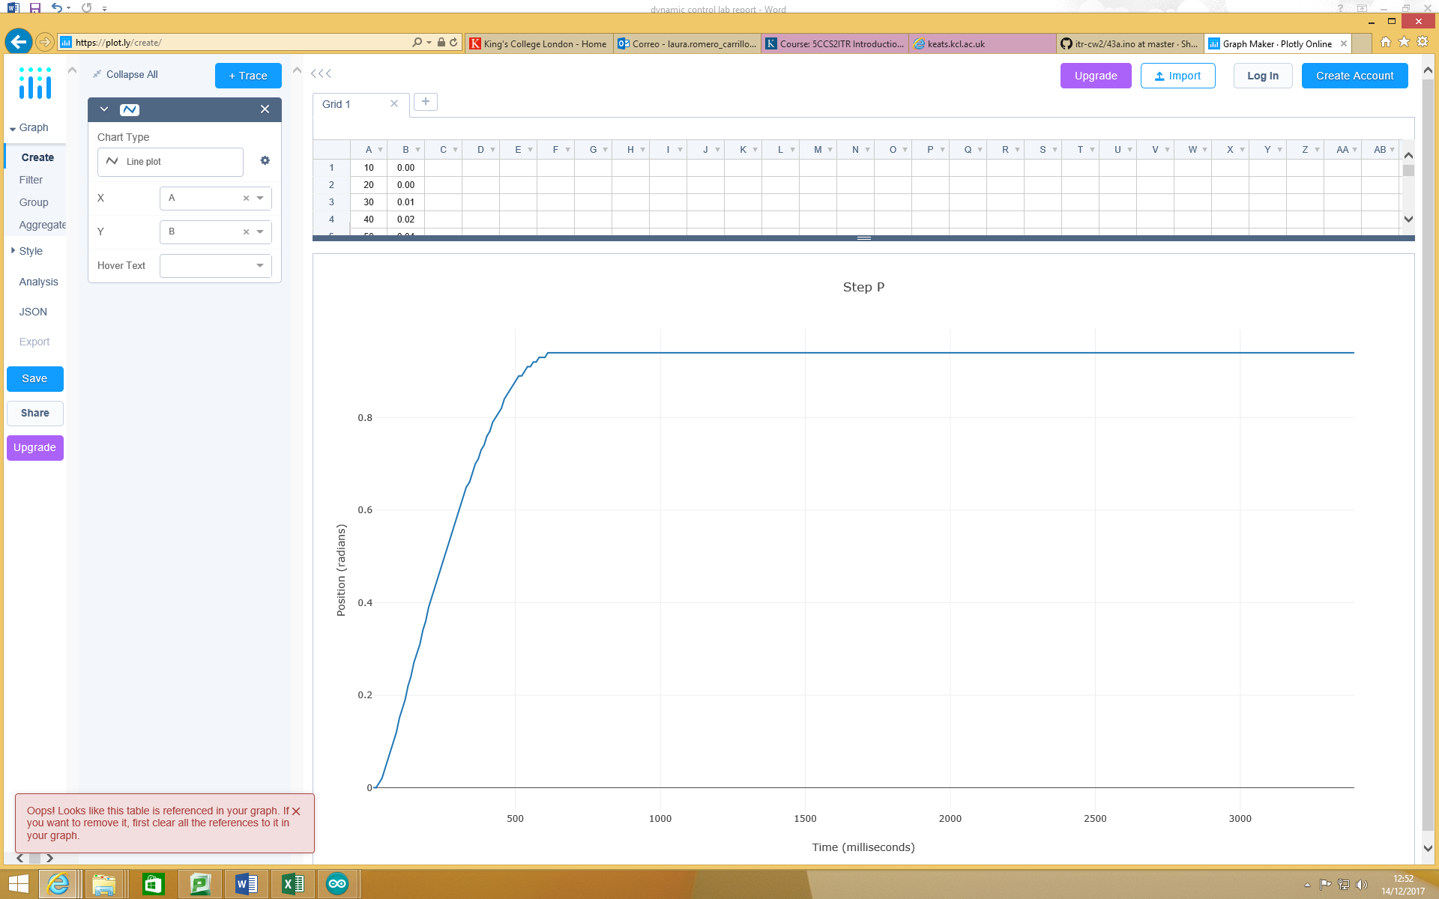

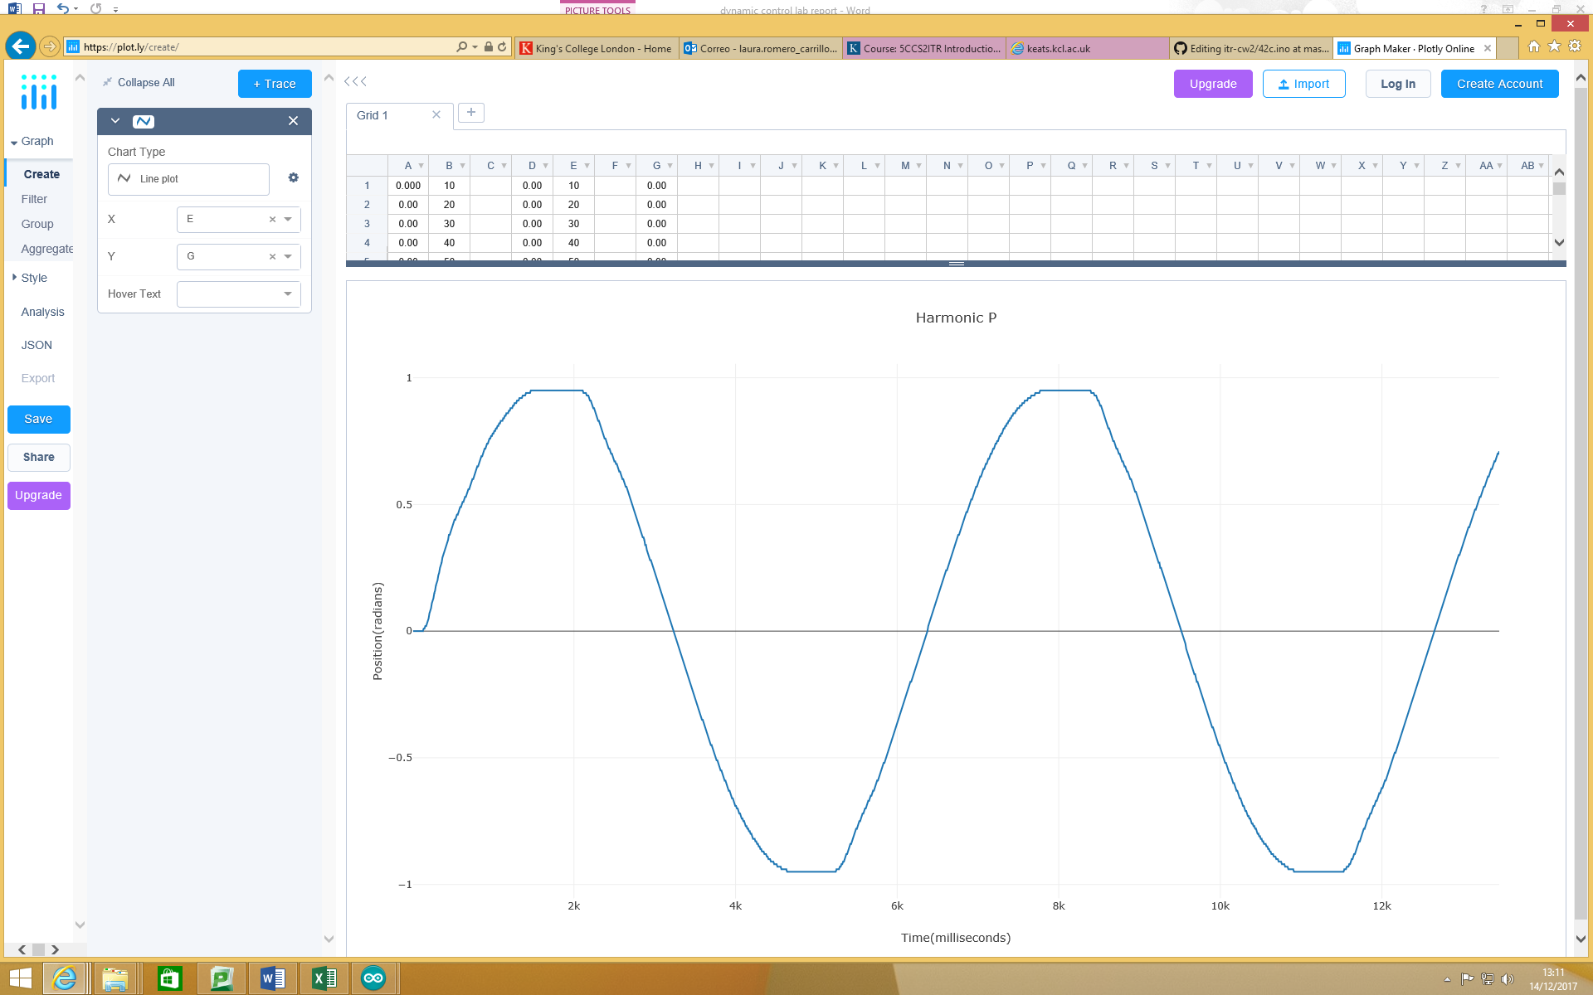

Adding a D term

In the step performance graph, the steady state error increased to 0.07 and it could not be tuned any further, however the rise time stayed the same. The rise time didn’t change from the previous graph. It didn’t affect it greatly. After turning Kd in the sine wave, the steady state error was the same range as the previous graph. The rise time was approximately 3100 which was the lowest value that would give us a succesful wave. It seems that tuning kd isn’t cauing a large amount of chnages to the graph.

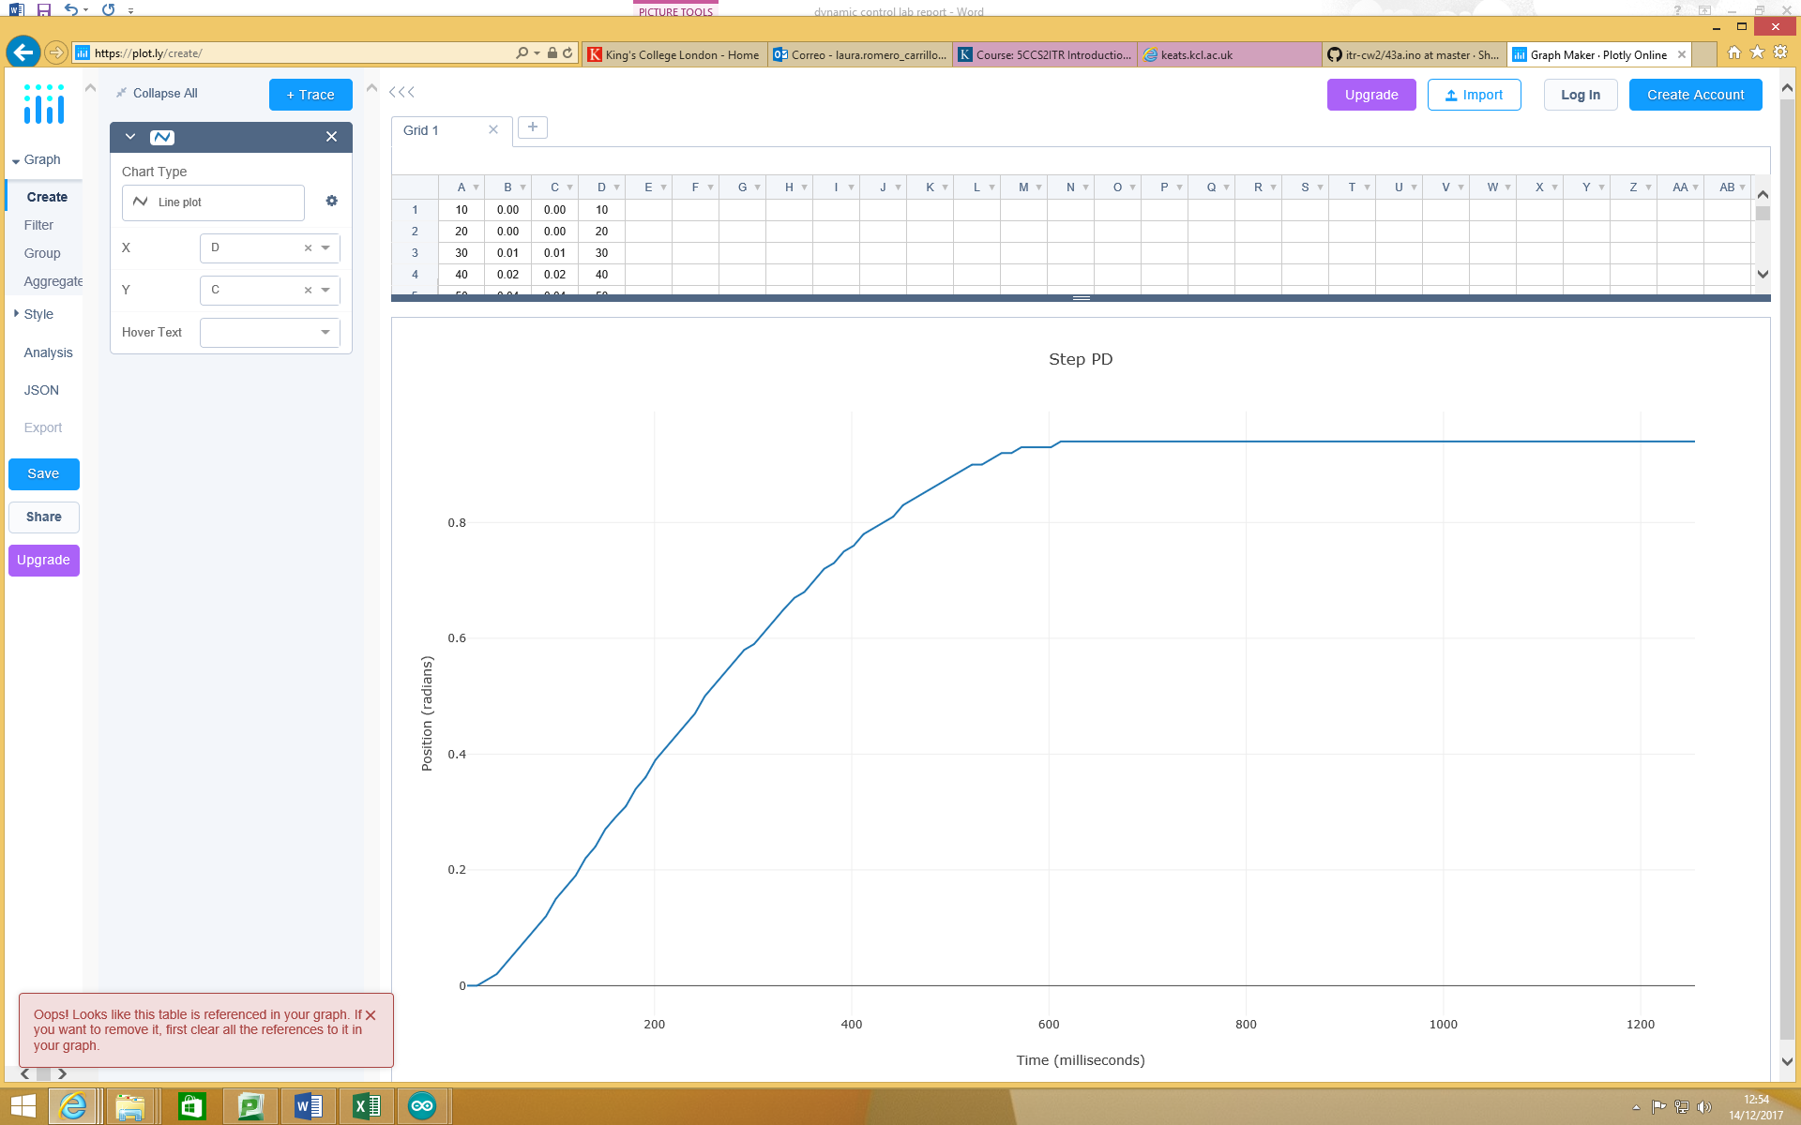

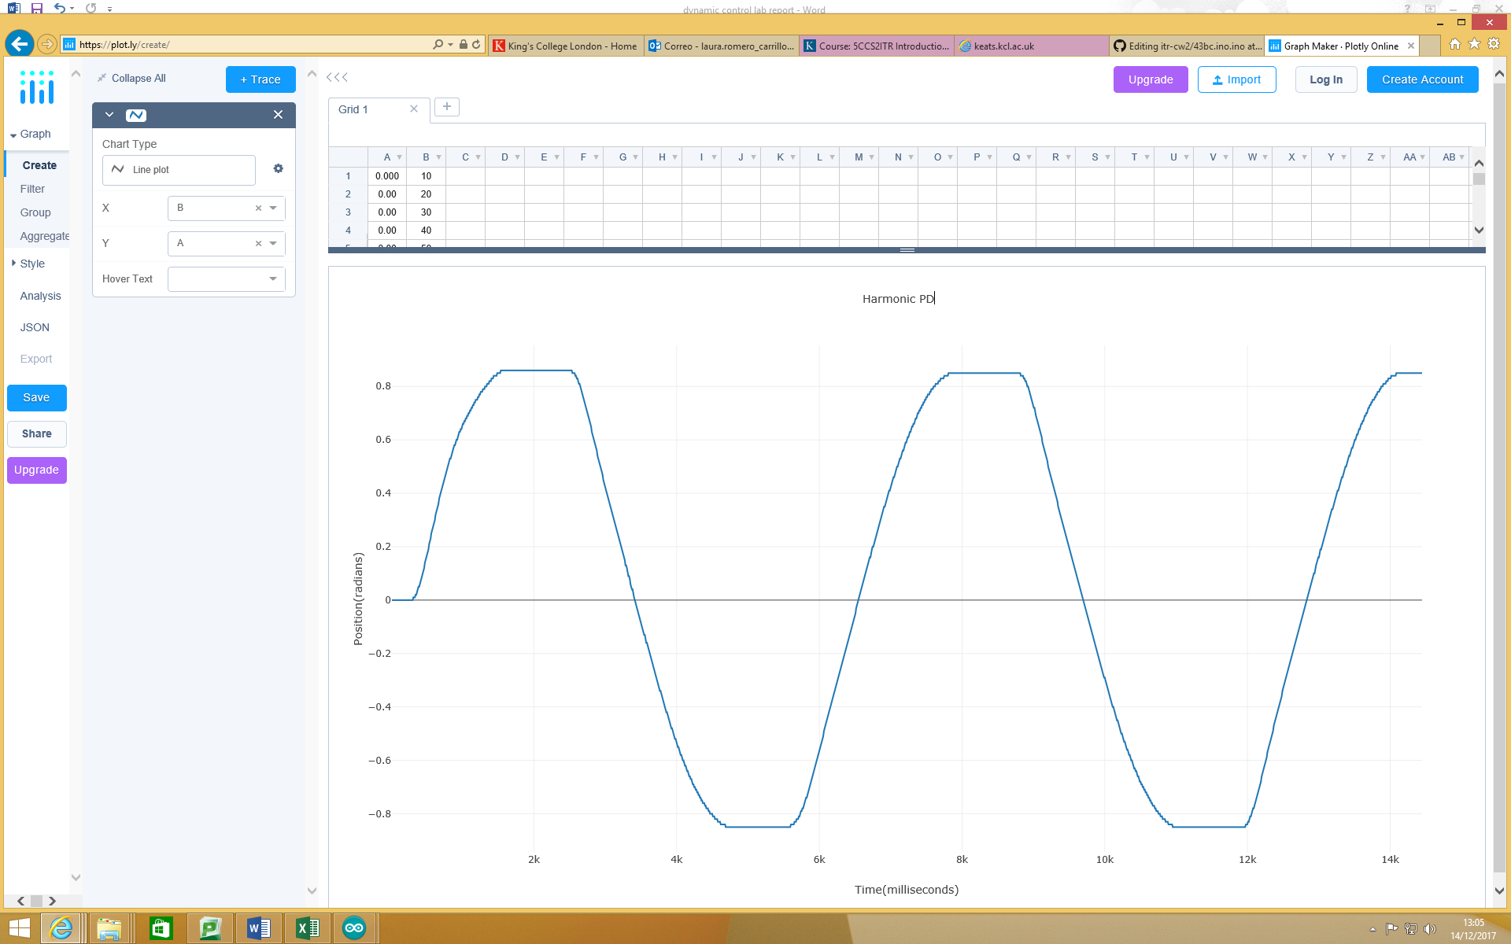

Using Gains

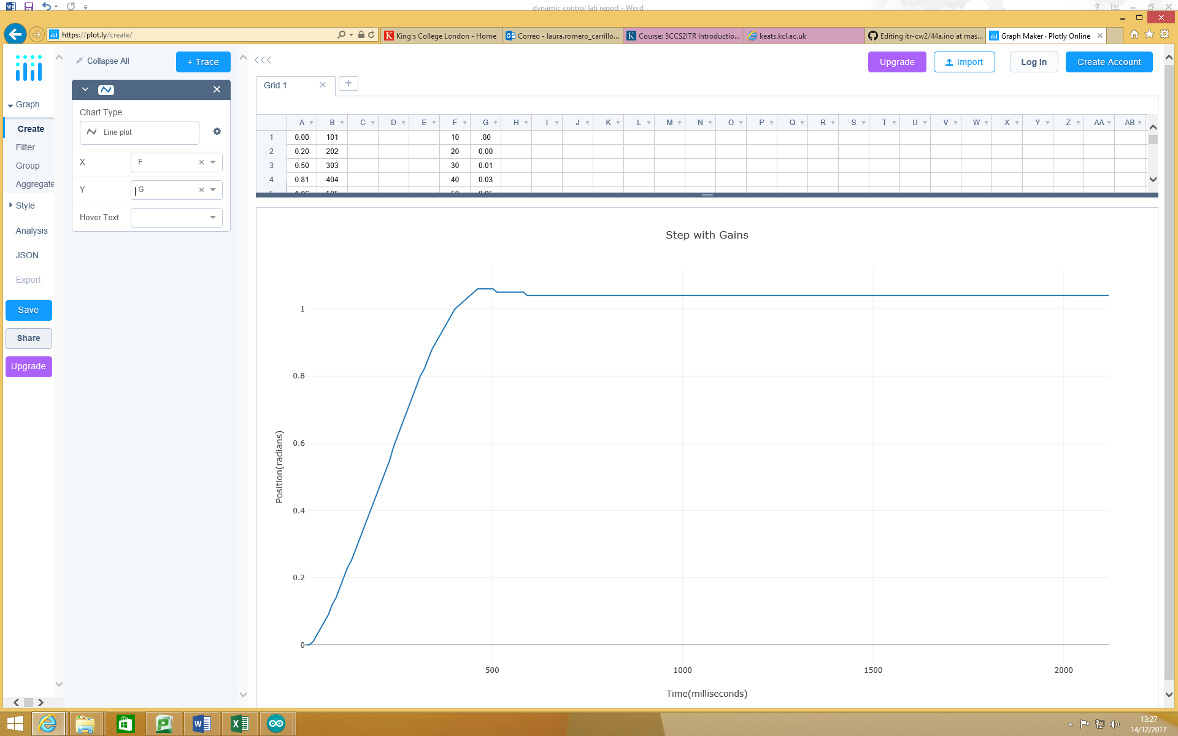

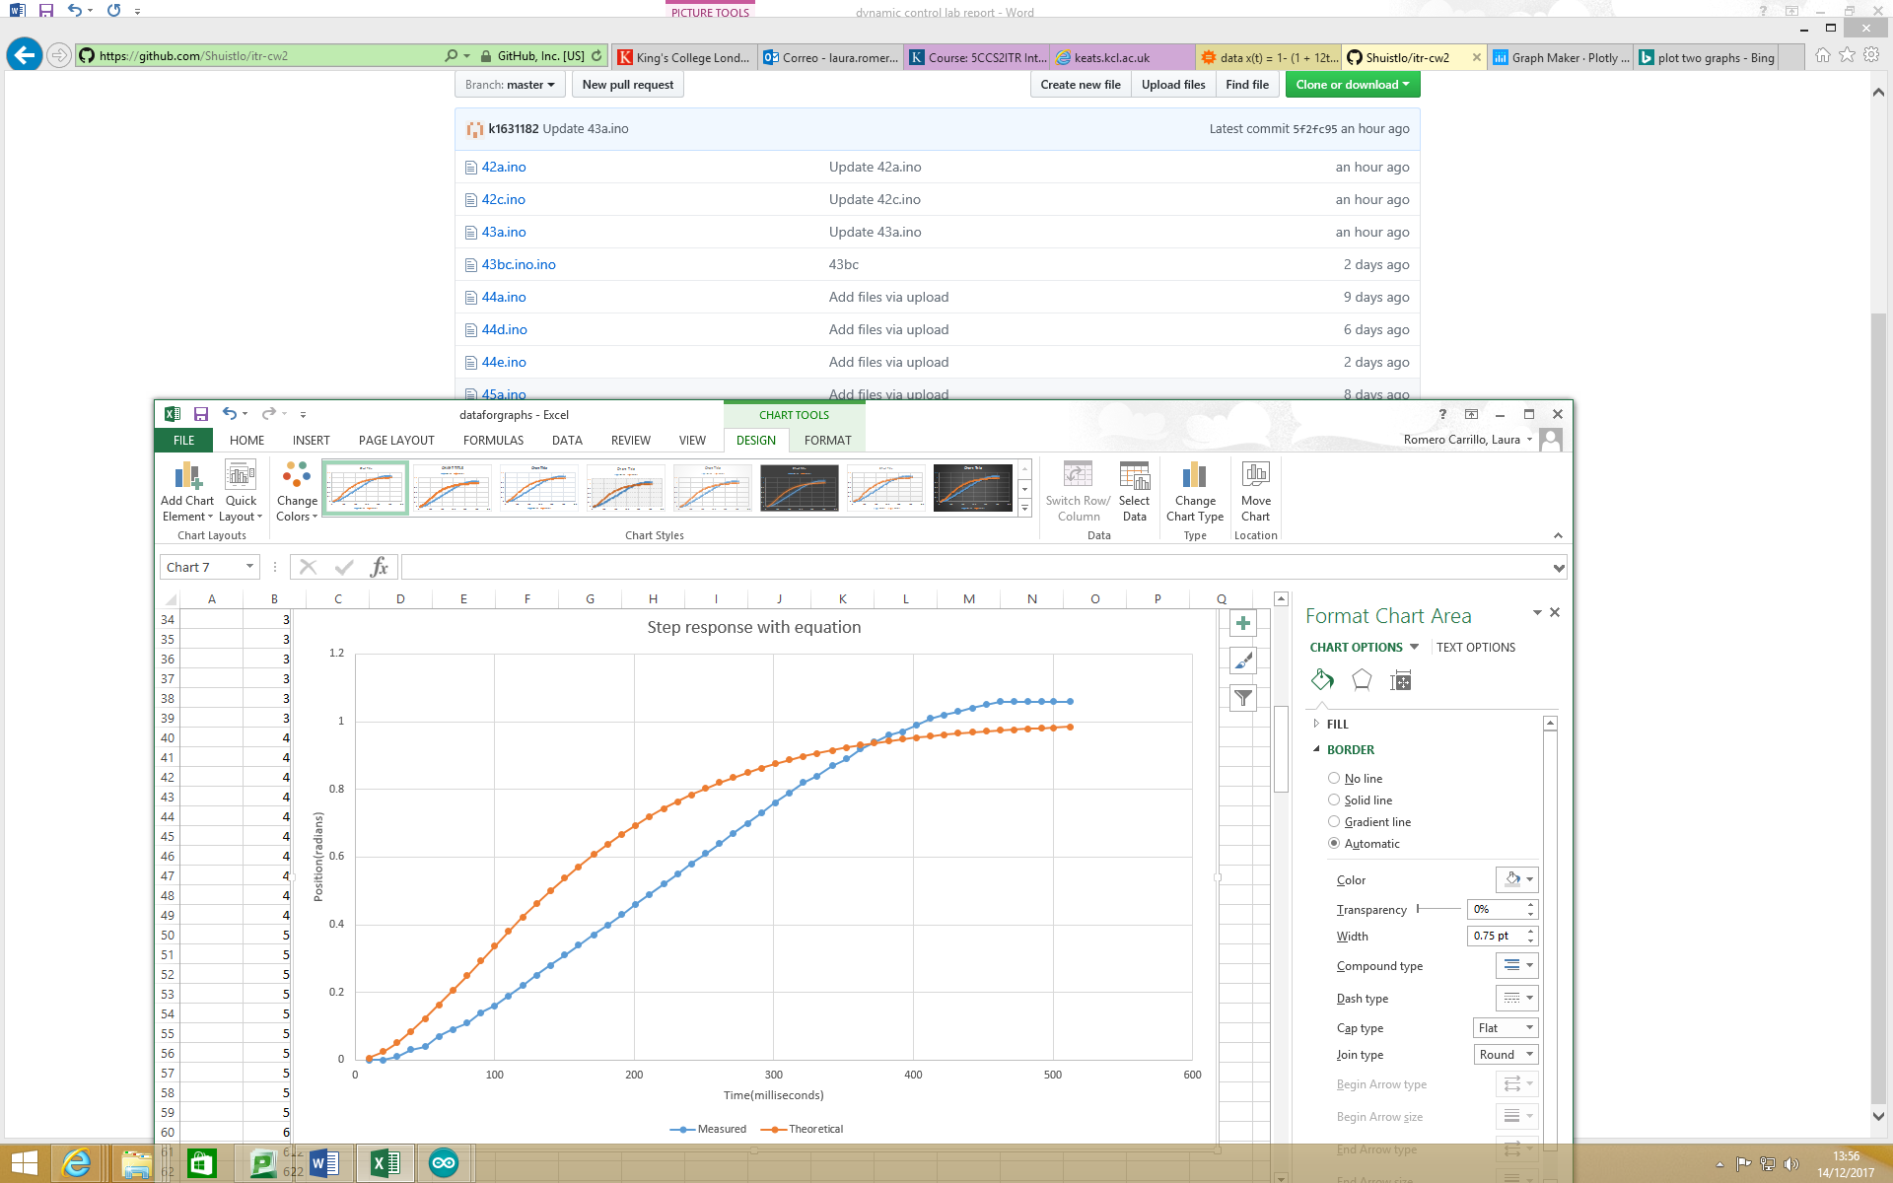

There is overshoot with the measured step response whilst the theoretical step response is more accurate and smooth.

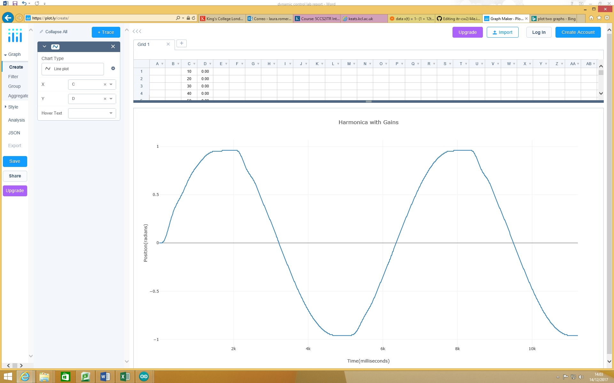

PID

For the sine wave the range steady state error had a smaller range than before, the maximum being -0.1 to 0.1, with a lot of very small values being frequent. The rise time remained the same as before, approximately 3100. For the values not including the integral we used the calculated gains to get the optimum values easily. We used 5 for the integral term.

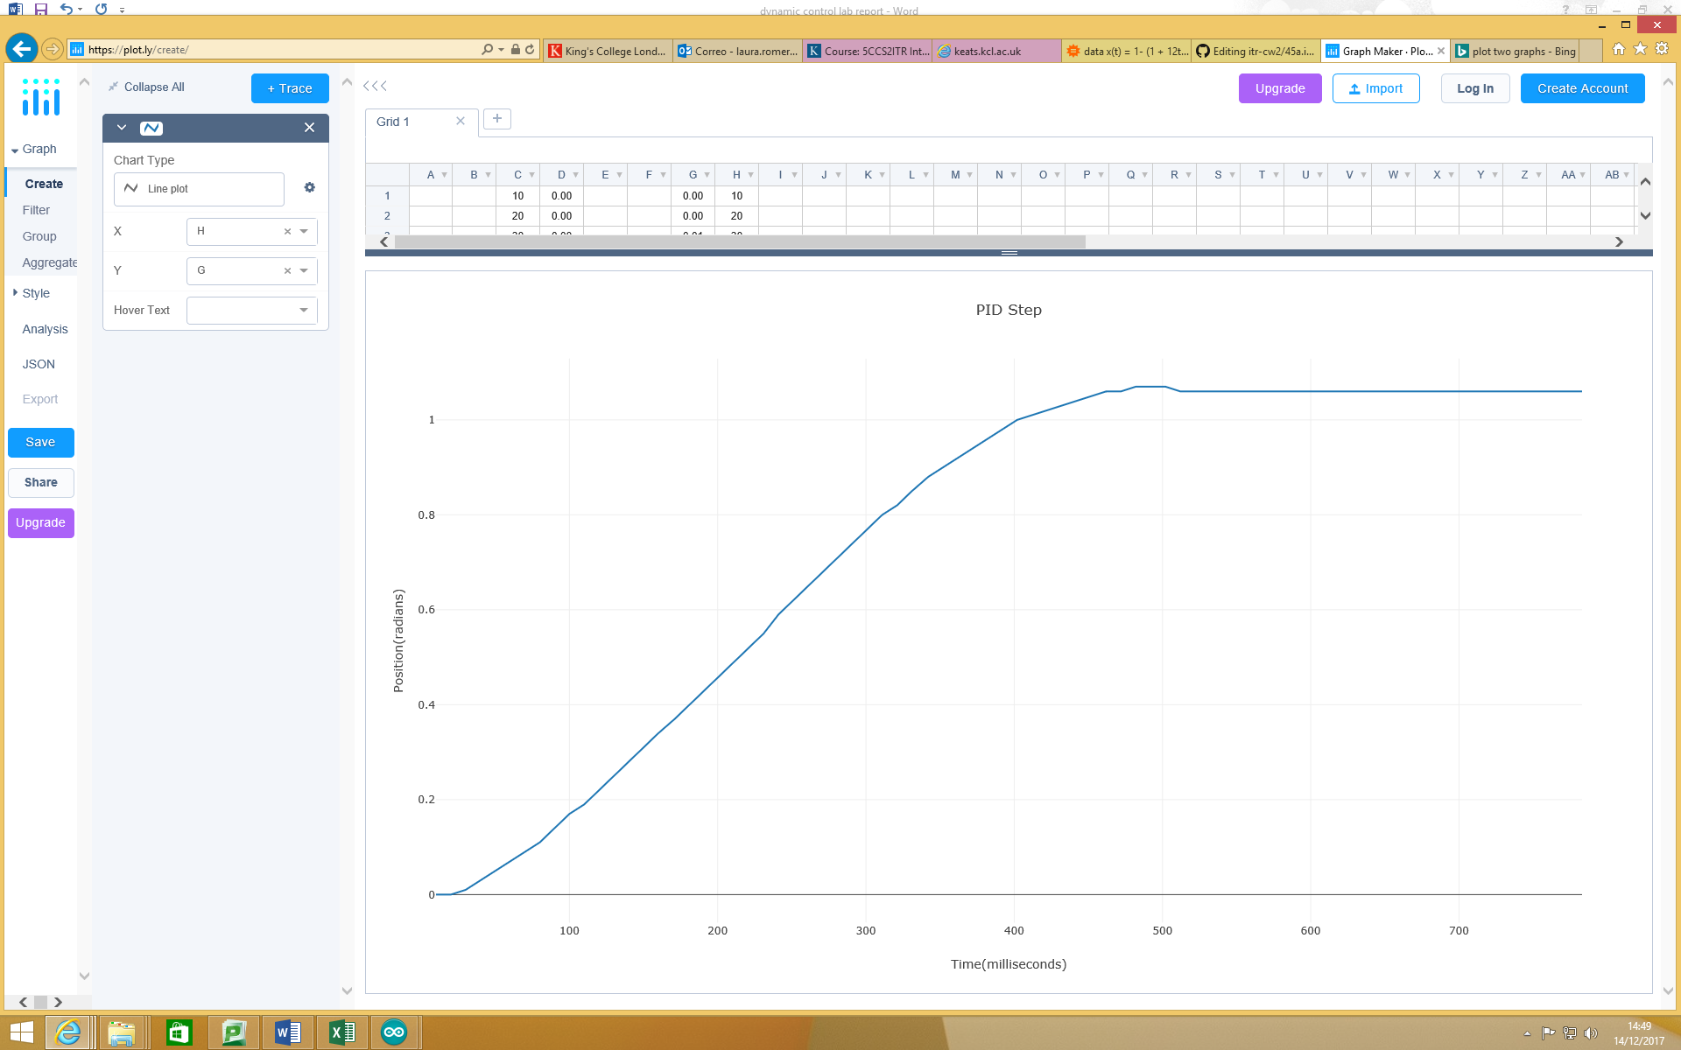

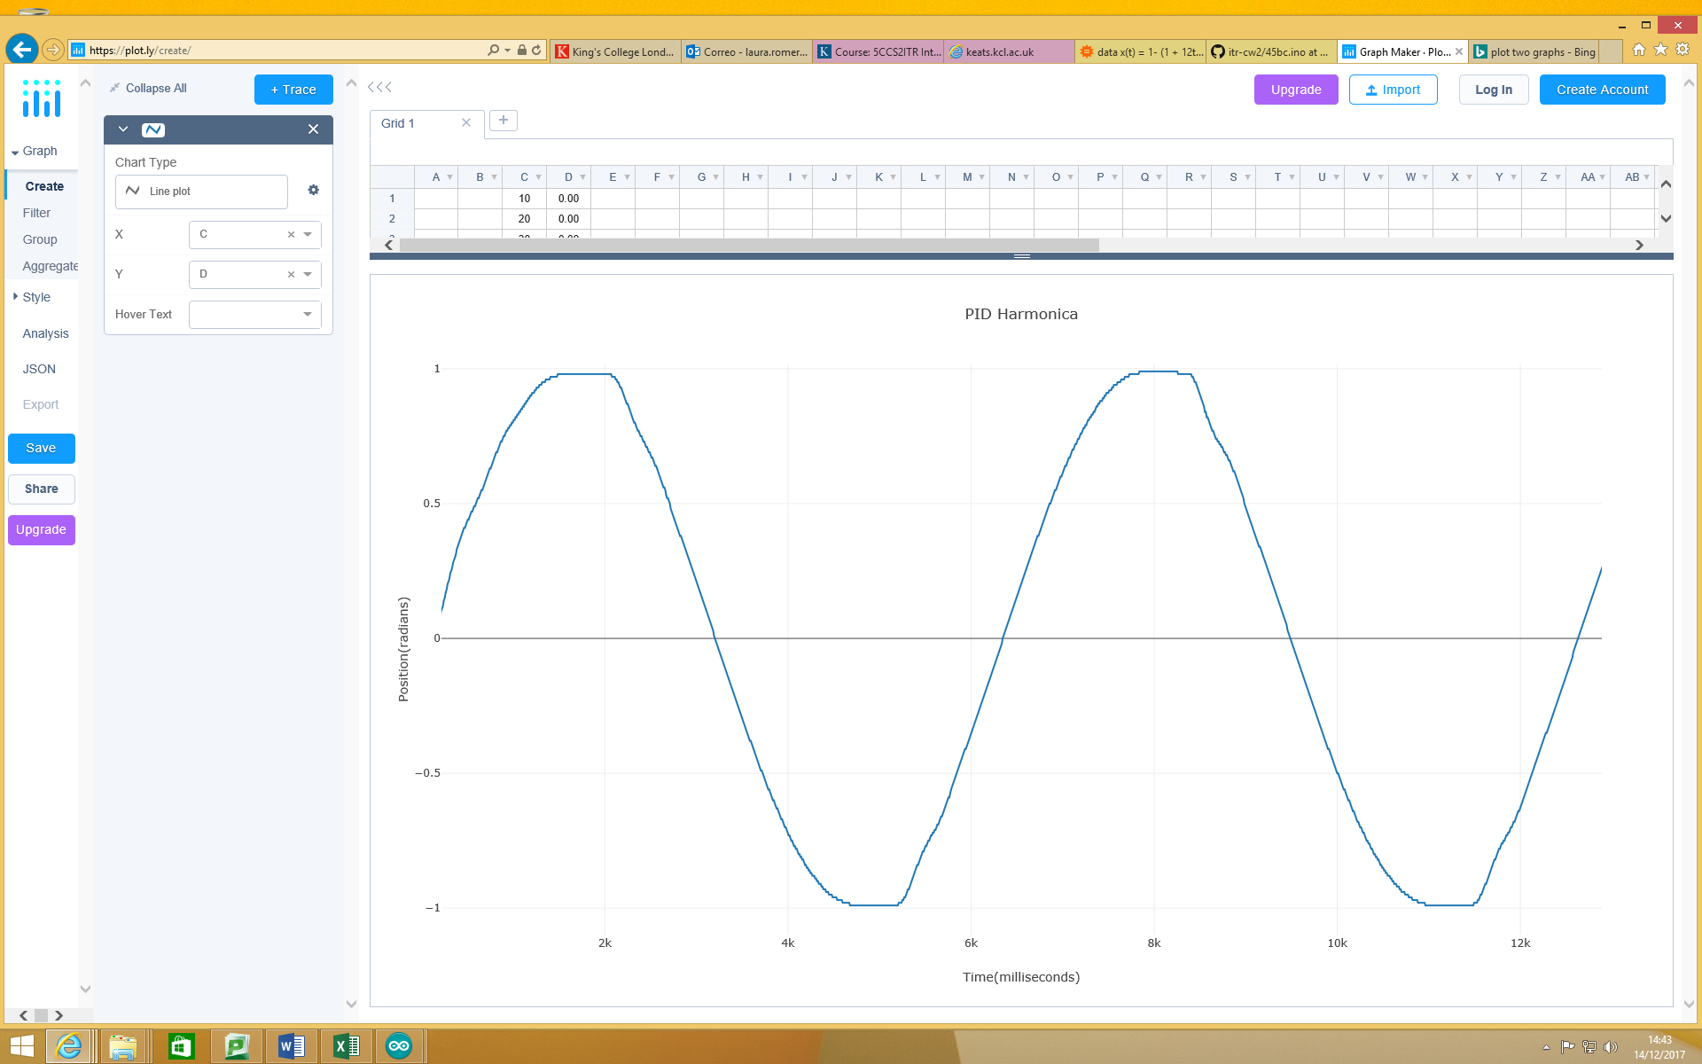

Sample Interval

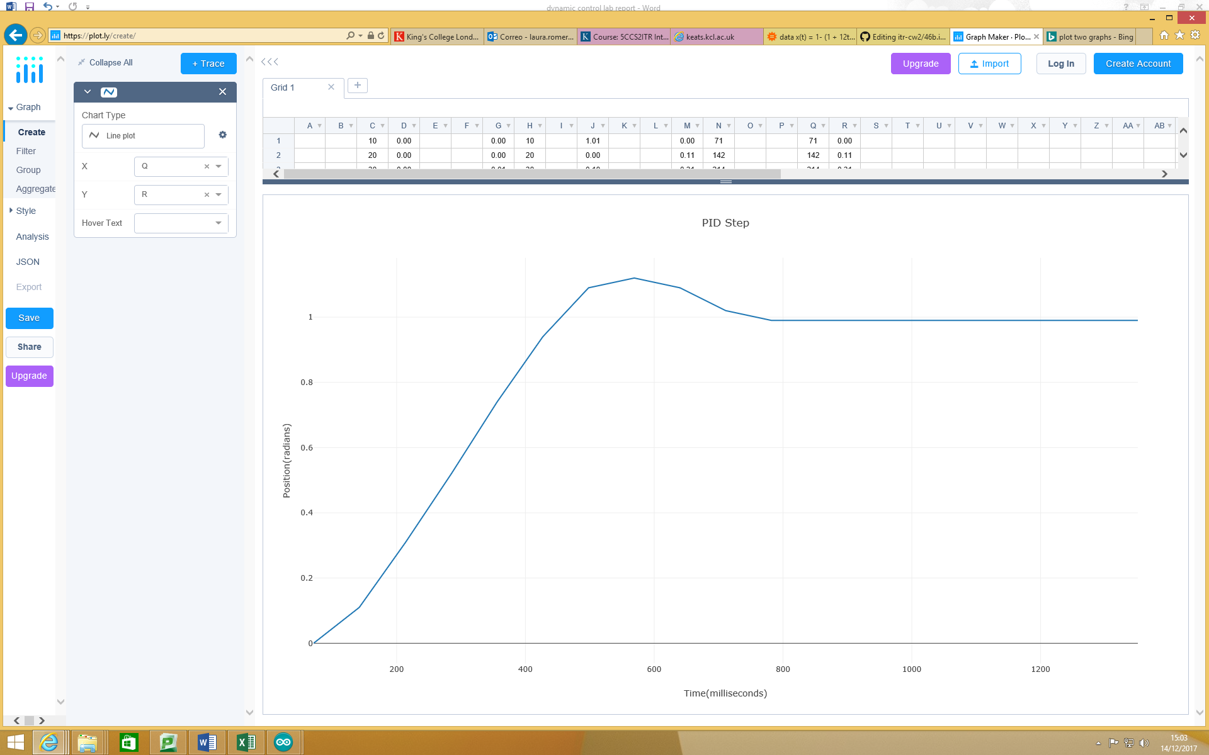

It is very unstable and big overshoot.

Si for 12 = 64

Si for 14 = 59

Si for 16 = 37

Si for 18 = 20

Si for 20 = 12

Effect of sample frequency

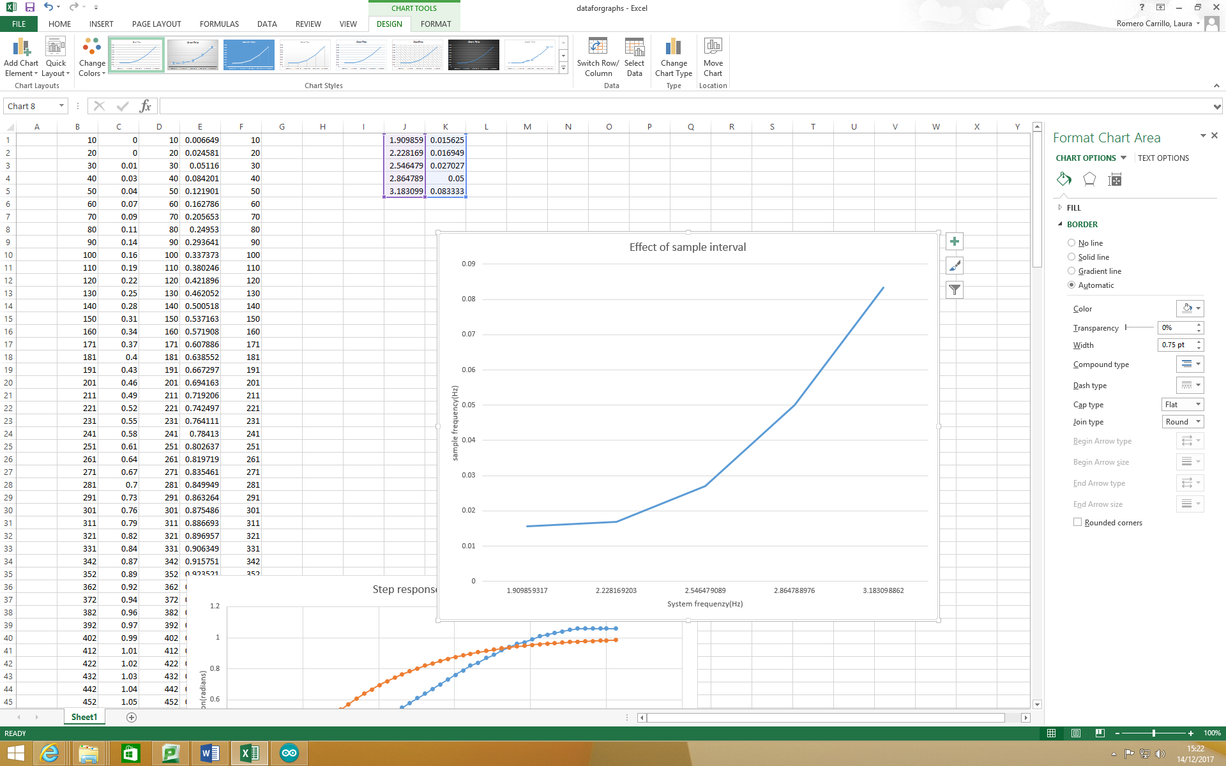

Discussion